1.

#include <stdio.h>

#include <time.h>

int calcFine(int d_day, int d_mon, int d_year, int r_day, int r_mon, int r_year) {

time_t d_time = mktime(&(struct tm) {.tm_mday = d_day,

.tm_mon = d_mon - 1,

.tm_year = d_year - 1900});

time_t r_time = mktime(&(struct tm){.tm_mday = r_day,

.tm_mon = r_mon - 1,

.tm_year = r_year - 1900});

int days_late = (int)(difftime(r_time, d_time) / (60 * 60 * 24));

return days_late > 0 ? days_late * 2 : 0;

}

int main() {

int d_day, d_mon, d_year, r_day, r_mon, r_year;

printf("Enter the due date (day month year): ");

scanf("%d %d %d", &d_day, &d_mon, &d_year);

printf("Enter the return date (day month year): ");

scanf("%d %d %d", &r_day, &r_mon, &r_year);

int fine = calcFine(d_day, d_mon, d_year, r_day, r_mon, r_year);

if (fine > 0) {

printf("The item is %d days late. Total fine: $%d\n", fine / 2, fine);

} else {

printf("No fine. The item is returned on time.\n");

}

}

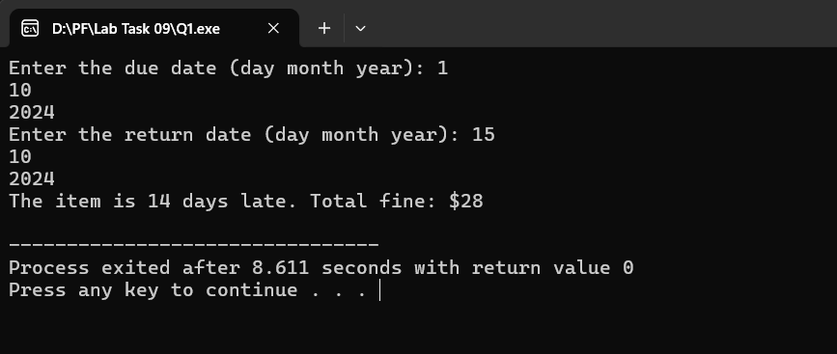

2.

#include<stdio.h>

#include<string.h>

void Palin()

{

int i,j,flag;

char str[5][20];

printf("Enter your list\n");

for(i=0;i<5;i++)

{

scanf("%s", str[i]);

}

for(i=0; i<5; i++)

{

flag =0;

for(j=0;j<strlen(str[i])/2;j++)

{

if(str[i][j] == str[i][strlen(str[i])-j-1])

{

flag = 1;

}

else

{

flag = 0;

break;

}

}

printf("Output:\n");

(flag)? printf("Palindrome\n"): printf("Not Palindrome\n");

}

}

int main()

{

Palin();

}

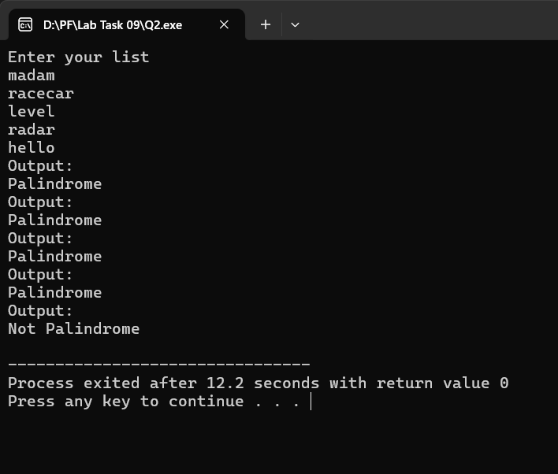

3.

#include<stdio.h>

void encryptMessage(char str[100], int n)

{

int i;

for(i=0;str[i] != '\0'; i++)

{

str[i] += n;

}

printf("Encrypted: %s\n", str);

}

void decryptMessage(char str[100], int n)

{

int i;

for(i=0;str[i] != '\0'; i++)

{

str[i] -= n;

}

printf("Decrypted: %s\n", str);

}

int main()

{

char str[100];

printf("Enter your string: ");

scanf("%s", str);

int n;

printf("Enter your shift number: ");

scanf("%d", &n);

encryptMessage(str, n);

decryptMessage(str, n);

}

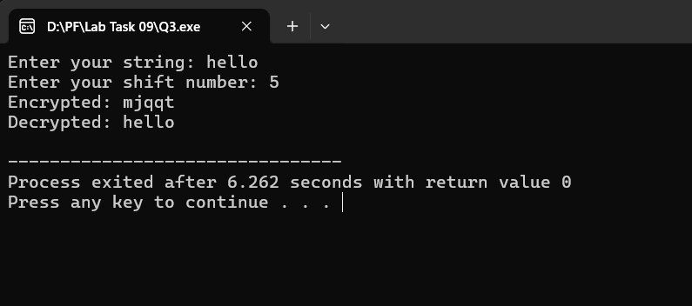

4.

#include<stdio.h>

int isprime(int n)

{

int i, flag =1;

for(i=2;i<n;i++)

{

if(n%i == 0)

{

flag = 0;

}

}

return flag;

}

int main()

{

int n;

scanf("%d", &n);

(isprime(n))? printf("Prime") : printf("Not Prime");

}

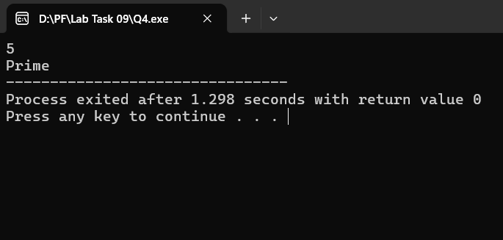

5.

#include<stdio.h>

void com(int *array1, int *array2, int len1, int len2) {

int *ptr1, *ptr2;

int found = 0;

for (ptr1 = array1; ptr1 < array1 + len1; ptr1++) {

for (ptr2 = array2; ptr2 < array2 + len2; ptr2++) {

if (*ptr1 == *ptr2) {

printf("%d ", *ptr1);

found = 1;

break;

}

}

}

}

int main() {

int array1[] = {1, 2, 3, 4, 5};

int array2[] = {4, 1, 8, 9, 0};

int len1 = sizeof(array1) / sizeof(array1[0]);

int len2 = sizeof(array2) / sizeof(array2[0]);

printf("Common elements:");

com(array1, array2, len1, len2);

}

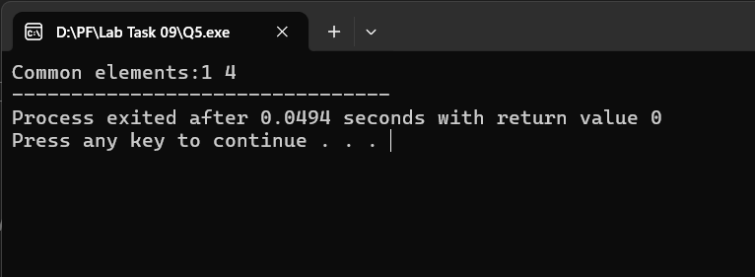

6.

#include<stdio.h>

#include<string.h>

void reverse(char *str)

{

int len = strlen(str),i;

char temp[len + 1];

for(i = 0; i < len; i++) {

temp[i] = str[len - 1 - i];

}

temp[len] = '\0';

printf("%s", temp);

}

int main()

{

char str[] = "Hello World";

reverse(str);

}

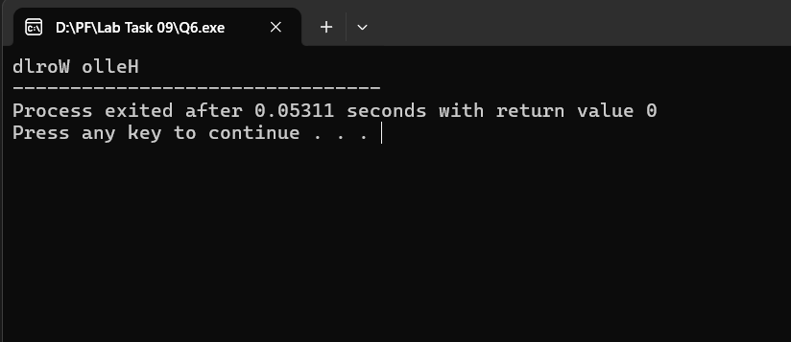

7.

#include<stdio.h>

#include<math.h>

float area(int r)

{

float ar = M_PI * pow(r, 2);

return ar;

}

int main()

{

int r;

printf("Enter radius: ");

scanf("%d", &r);

float result = area(r);

printf("Area: ");

printf("%f", result);

}

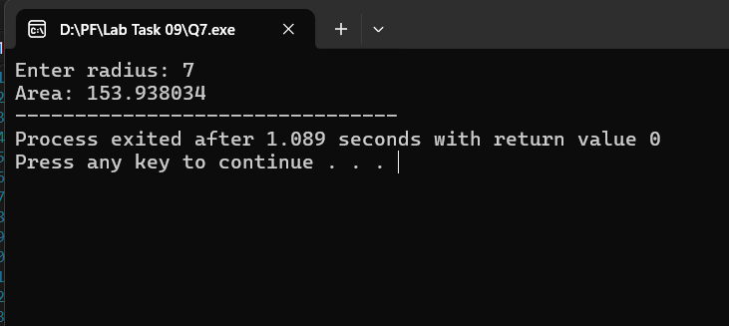

8.

#include <stdio.h>

int minmax(int * arr)

{

int *ptr = arr;

int size = sizeof(arr) / sizeof(arr[0]);

int min = *ptr, max = *ptr;

for (ptr = arr; ptr < arr + size; ptr++) {

if (*ptr < min) {

min = *ptr;

}

if (*ptr > max) {

max = *ptr;

}

}

printf("Min %d\n", min);

printf("Max %d", max);

}

int main() {

int arr[] = {99,6,8,1};

minmax(arr);

}

